Second Sight - Assistance for Visually Impaired

Rachit Mittal, Sambhav Badaya, Tanishq Gupta, Hardik Jain
RV College of Engineering, Bengaluru, India
Email: rachitmittal.ai24@rvce.edu.in

ABSTRACT
Blind and visually impaired (BVI) individuals face daily challenges in safe navigation, understanding nearby obstacles, reading printed text, recognizing currency, and performing secure financial transactions without external assistance. This paper presents Second Sight, an iOS-based assistive application that combines ARKit camera capture, Apple Vision and Core ML obstacle detection, filtered OCR, TensorFlow Lite currency recognition, and secure QR-based payments. The updated currency module uses a MobileNetV2-based six-class Indian banknote classifier with OCR support, explicit note-presence gating, confidence-margin rejection, and temporal consensus. The text-reading pipeline rejects keyboard fragments and lexical noise before offering user-controlled speech. The AI-powered Describe feature sends the current camera image through a backend proxy to MiniCPM-V 4.6 in LM Studio and speaks a concise scene summary. QR Pay Mode requires allowlisted QR payloads, manual amount entry, and Face ID authorization. A Node.js/Express backend with MongoDB persistence, optional Telegram notifications, and a React dashboard complete the modular assistive platform.
Keywords: Assistive technology, visual impairment, ARKit, Core ML, TensorFlow Lite, MobileNetV2, Vision OCR, currency recognition, MiniCPM-V, QR scanning, Face ID, digital wallet.
I. INTRODUCTION
Independent mobility and safe navigation remain fundamental requirements for blind and visually impaired (BVI) individuals; however, real-world environments are highly dynamic and contain obstacles that are difficult to perceive through traditional aids alone. Everyday spaces such as corridors, classrooms, streets, and public transport areas include moving people, furniture, walls, doors, and vehicles, which can cause collisions and unsafe movement if not detected early. In addition to navigation, BVI users frequently face difficulty reading signboards, labels, and printed instructions, which restricts access to information in public and private environments. Financial independence is another major concern, as identifying currency denominations and completing digital payments often requires assistance from others, introducing risks related to privacy and transaction security.
Existing assistive approaches such as white canes provide tactile feedback but are limited in range and cannot provide semantic information about objects. Wearable solutions such as smart glasses and sensor-based systems offer improved perception but require additional hardware and cost, making them less accessible. Smartphone-based assistive applications provide a promising alternative because modern devices support powerful cameras, on-device inference, and built-in accessibility tools. Apple’s ARKit provides continuous camera capture and spatial understanding capabilities, while Vision and CoreML enable efficient deployment of deep learning models for object detection and recognition tasks. However, many existing mobile assistive systems focus on only one aspect, such as obstacle detection or OCR, and do not provide a unified solution that supports navigation, reading, and secure financial interaction within a single workflow.
To address these challenges, this paper proposes Second Sight, a unified iOS assistive system for real-time navigation support, contextual text reading, Indian currency identification, optional vision-language scene description, and secure wallet transfers. The system performs on-device YOLO obstacle detection, filters OCR output before user-controlled reading, and recognizes six Indian banknote denominations using a TensorFlow Lite classifier combined with OCR and rejection logic. QR payments are restricted to allowlisted codes and require Face ID authorization. The remainder of this paper describes the architecture, methodology, implementation, measured model comparison, limitations, and future enhancements of Second Sight.

II. Related Work
Assistive systems for visually impaired users have been explored using sensor-based smart canes, wearable devices, and computer vision solutions. Ultrasonic and proximity sensor approaches provide basic obstacle alerts but do not classify objects. Vision-based methods using deep learning models such as YOLO have demonstrated strong real-time detection performance and can be deployed on mobile devices using optimized inference frameworks. OCR-based applications assist in reading printed text; however, continuous auto-reading may overwhelm users and requires controlled interaction. Currency recognition has been studied using OCR-only and deep learning approaches, but both methods can fail under low lighting, blur, or partial occlusion; hybrid techniques improve robustness.
Digital wallet systems are widely used, but secure transaction authorization is critical when a visually impaired user may depend on assistance from another person. Therefore, biometric authentication and explicit user confirmation steps are necessary to prevent misuse. Second Sight addresses these requirements by combining on-device perception pipelines with an authenticated QR-based wallet transfer mechanism.

III. SYSTEM OVERVIEW
Second Sight is an integrated platform consisting of an iOS SwiftUI application, a backend service, and a web dashboard. ARKit publishes camera frames to mode-specific perception modules. YOLO obstacle detection runs through Vision and Core ML, text extraction uses Vision OCR with semantic filtering, and Indian currency classification runs through TensorFlow Lite. QR scanning supports secure payment initiation. The named Describe feature captures the current frame, compresses it as an image, and sends it to a backend perception endpoint. The backend forwards the multimodal request to MiniCPM-V 4.6 hosted in LM Studio on a networked Mac, and the returned concise scene summary is spoken through the app. Mode-based execution limits competing workloads and excessive speech.
The backend wallet service is implemented using Node.js and Express and provides REST endpoints for wallet balance management and transaction execution. MongoDB is used as the persistent database layer to store wallet state and maintain transaction history. The backend also integrates an optional Telegram notification service to deliver transaction alerts. The React dashboard is implemented as a web application that communicates with the backend to display wallet balance and transaction history and to support manual wallet operations. The dashboard uses periodic polling to refresh data in near real time, ensuring that wallet updates triggered by the iOS application are reflected promptly.
A key feature of Second Sight is the secure QR Pay Mode, which enables wallet transfers through a strict authentication pipeline. QR Pay Mode is designed to avoid unsafe payments by enforcing allowlist-based QR validation, manual amount entry, and Face ID biometric authorization. In this mode, all other detection pipelines are paused to ensure stable QR recognition and to maintain a focused user experience. Through this architecture, Second Sight provides a unified assistive system that combines navigation safety, information access, and secure financial interaction in a single platform.

IV. SYSTEM ARCHITECTURE

- iOS Application Architecture

The iOS application of Second Sight follows a modular architecture where camera capture, perception services, speech feedback, and transaction logic are implemented as independent components coordinated by a central controller. The application entry point is implemented using SwiftUI, where blind_navigationApp.swift initializes the main window and loads the primary view. The core orchestration is implemented in ContentView.swift, which maintains recognition mode state, subscribes to camera frame updates, triggers detection services, and manages user interactions through gestures. ContentView is also responsible for coordinating speech prompts, handling QR scanning results, presenting amount entry overlays, executing Face ID authorization, and calling backend wallet endpoints.
The camera subsystem is managed through ARCameraService.swift, which owns the ARKit session and continuously publishes the latest camera frame as a CVPixelBuffer. The camera preview is displayed through CameraPreview.swift, which wraps the AR view and allows the application to show overlays for development and debugging. The published frame stream is consumed by the recognition modules, enabling real-time processing while maintaining consistent synchronization across services.

- Obstacle Detection Module

Obstacle detection is implemented through DetectionService.swift using a YOLO CoreML model packaged as yolo11n.mlpackage. Each incoming frame is processed using a Vision-based CoreML request to produce detected objects with labels, confidence values, and normalized bounding boxes. To improve reliability in real-time operation, the detection results are filtered using confidence thresholds and stabilized using smoothing and non-maximum suppression to reduce duplicates. Since speech feedback must remain understandable and not overwhelming, Second Sight announces only a subset of critical object classes such as persons, furniture, walls, doorways, and vehicles. Spatial guidance is provided by estimating relative object position based on bounding-box location and approximating distance using bounding-box size heuristics, enabling navigation-oriented prompts that assist users in avoiding collisions.

- OCR Text Recognition Module

Text recognition is implemented in TextRecognitionService.swift using Vision OCR in accurate mode with language correction. Observations below 0.55 confidence, very small regions, fragmented single-character sequences, keyboard-row patterns, and lexically unrecognizable text are rejected. Useful signs, numbers, prices, and common abbreviations remain eligible. The system announces that meaningful text is available and waits for a tap; the selected text is validated again immediately before speech.
- AI-Powered Describe Feature
Describe provides semantic scene understanding beyond fixed object labels. When invoked, MiniCPMService captures the current ARKit frame, converts it to a compressed JPEG, and sends it with a navigation-focused prompt to the backend /api/perception/analyze endpoint. The backend uses the OpenAI-compatible LM Studio API to run the vision-capable MiniCPM-V 4.6 model. The response is reduced to a concise description of important objects, layout, and navigation-relevant context, then delivered through AVSpeechSynthesizer. Unlike obstacle and currency inference, Describe is not fully on-device and requires the Mac, backend, LM Studio server, and loaded model to be reachable on the same network.

- Currency Recognition Module

Currency recognition is implemented in CurrencyRecognitionService.swift using a MobileNetV2-based TensorFlow Lite classifier and OCR parsing. The model supports ₹10, ₹20, ₹50, ₹100, ₹200, and ₹500 notes; ₹2000 is not included because that class is absent from the training dataset. A Vision rectangle request first checks for a banknote-like object. Classification is accepted only above 0.85 confidence, with at least a 0.25 lead over the second-ranked class, and after two consecutive matching frames. Brightness gating and OCR evidence provide additional safeguards. Currency mode announces the denomination only and does not mutate wallet balance.

- Secure QR Pay Mode and Authentication Module

Second Sight introduces a secure QR Pay Mode designed to support wallet transfers in a safe and accessible manner. QR scanning is implemented using QRScanService.swift, which detects QR codes using Vision’s barcode detection request. To prevent unintended transfers, Second Sight enforces an allowlist-based validation mechanism where only predefined QR payload strings are accepted. Since QR payloads may contain minor formatting differences, normalization rules are applied to ensure robust matching across variations such as whitespace, case differences, protocol changes, and trailing slashes. When an allowlisted QR code is detected, the system prompts the user to enter the payment amount manually, ensuring that the QR itself does not encode transaction value. The system speaks the entered amount aloud as an additional confirmation step before initiating Face ID authentication through the LocalAuthentication framework. Payments are executed only when Face ID succeeds under biometrics-only authorization, preventing helpers from sending money without the blind user’s consent. During QR Pay Mode, all other recognition modules are paused, ensuring stable QR scanning and preventing noisy overlays and speech prompts.

- Backend Wallet Service and Dashboard Architecture

The backend wallet service is implemented using Node.js and Express, where server.js initializes the server, configures middleware, establishes MongoDB connectivity, and mounts wallet routes. Wallet operations such as balance retrieval, adding funds, sending money, and transaction listing are implemented in routes/wallet.js. Persistent storage is handled using MongoDB models including a wallet state model and a transaction history model. Telegram notifications are implemented through a dedicated service module that sends transaction alerts using a bot token and chat identifier. The React dashboard provides a monitoring interface that fetches wallet balance and transactions using an Axios-based API client and refreshes the display using periodic polling. This ensures that transactions triggered from the iOS application are visible on the dashboard within short time intervals.

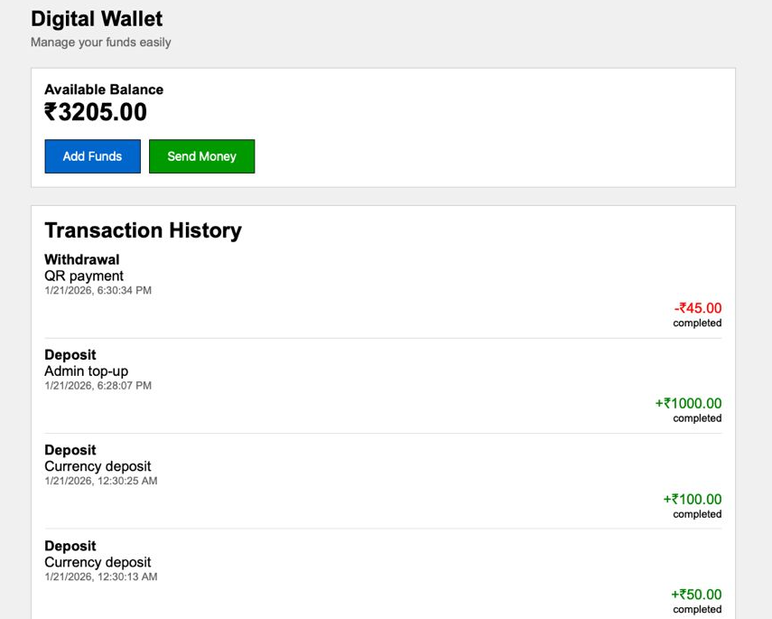
Fig 4.1

V. METHODOLOGY and FLOWCHART

- iOS Application Implementation

The Second Sight iOS application is implemented using SwiftUI. ContentView.swift coordinates camera input, recognition modes, gestures, and speech. ARKit frames are selectively routed to Core ML obstacle detection, filtered Vision OCR, TensorFlow Lite currency recognition, QR scanning, and the optional backend-proxied MiniCPM-V description service. This modular mode-based design maintains responsive processing and understandable feedback.
To ensure the camera feed is continuously available for real-time inference, the system uses ARKit-based camera capture through ARCameraService.swift. This service owns the AR session and publishes the latest camera frame buffer as a CVPixelBuffer, which is directly consumable by Apple Vision requests and CoreML inference pipelines. The live preview is rendered through CameraPreview.swift, which wraps the AR view into a SwiftUI component. Although the target user may not rely on the visual preview, this layer supports debugging overlays such as bounding boxes for detections, text regions, and QR state indicators, which are essential during development and evaluation.

- Object Detection and Navigation Feedback Implementation

Obstacle detection in Second Sight is implemented using a YOLO-based model packaged as yolo11n.mlpackage. The inference pipeline is implemented in DetectionService.swift using Vision’s VNCoreMLRequest, which executes the CoreML model on each frame. The raw detection results produced by the model consist of recognized objects represented by bounding boxes and confidence scores. Since continuous real-time inference can produce duplicate or unstable detections, the implementation includes confidence thresholding and non-maximum suppression to remove redundant detections. Additionally, smoothing is applied to improve temporal consistency, which reduces rapid fluctuations in bounding box positions and object labels across consecutive frames.
For accessibility, Second Sight converts detection results into speech-friendly navigation cues. Only a subset of classes that strongly impact safe navigation are announced, such as people, furniture, walls, doorways, and vehicles. This selective strategy avoids overwhelming the user with irrelevant detections and improves the clarity of spoken guidance. Object position is estimated using the horizontal midpoint of the bounding box, which allows the system to categorize obstacles as being on the left, center, or right of the user’s view. Distance estimation is implemented as a heuristic based on bounding box size, where larger objects are assumed to be closer. Although this approach does not provide precise depth measurements, it offers practical approximate guidance that can help users adjust movement direction and speed in real time.

- OCR and Text Reading Implementation

Text recognition uses VNRecognizeTextRequest in accurate mode with language correction. A 0.55 confidence threshold, minimum region area, and observation-level semantic checks suppress OCR noise. The filter rejects keyboard rows such as QWERTY/ASDF, heavily fragmented single-letter sequences, and dictionary-unrecognized jargon while preserving meaningful signs, monetary values, and common abbreviations. Second Sight prompts before reading and repeats the filter when the user taps, preventing stale or noisy text from reaching AVSpeechSynthesizer.
When the user taps after a text prompt, Second Sight validates the assembled text again and uses SpeechService.swift with AVSpeechSynthesizer to read only accepted content. Cooldowns prevent repeated prompts, and OCR pauses during speech to avoid overlapping announcements. This two-stage validation is particularly important for keyboards and control panels, where OCR may otherwise concatenate individual keys into meaningless speech.
D. AI-Powered Describe Feature Implementation
The Describe workflow is implemented through MiniCPMService. The service throttles scene requests, encodes the latest CVPixelBuffer as a compressed image, and submits a mode-specific prompt and optional OCR context to the backend. The backend is configured for the LM Studio OpenAI-compatible chat-completions endpoint using the minicpm-v-4.6 model identifier. On success, the app stores the returned summary and speaks it, while duplicate summaries and rapid repeat requests are suppressed by cooldown logic.

E. Currency Recognition

Currency recognition in Second Sight uses the trained IndianCurrency.tflite model through a pinned TensorFlow Lite Swift runtime. The model receives a 224 × 224 float32 RGB image and returns probabilities for six denominations: ₹10, ₹20, ₹50, ₹100, ₹200, and ₹500. OCR independently extracts rupee symbols and denomination digits. The previous 299 × 299 Core ML classifier, which included ₹2000, was removed after comparative testing showed substantially lower accuracy on the shared held-out benchmark.
To prevent a closed-set classifier from assigning a denomination to an empty table or unrelated object, the pipeline first requires a banknote-like rectangle or explicit OCR currency evidence. Model-only decisions require confidence ≥0.85 and a top-two probability margin ≥0.25. Two consecutive frames must agree; changing predictions reset consensus, and frames without note evidence clear pending detections. Brightness gating remains active. A double tap enables currency mode, and confirmed denominations are spoken without changing wallet balance.

F. QR Pay Mode and Secure Transfer Implementation

The QR Pay feature in Second Sight is implemented as an exclusive mode designed specifically for secure financial transactions. QR Pay Mode is activated using a long-press gesture, which toggles QR scanning on and disables all other recognition pipelines including object detection, OCR, and currency recognition. This exclusivity is critical because running multiple Vision and CoreML pipelines simultaneously can reduce frame processing stability and increase the chance of missing QR detections. By pausing other pipelines, Second Sight ensures that QR scanning receives full processing priority and that the user experience remains focused on payment execution.
QR scanning is implemented through QRScanService.swift using Vision’s VNDetectBarcodesRequest. When a QR code is detected, the system extracts its raw payload string. To prevent unauthorized transfers, Second Sight implements allowlist-based validation, where only predefined QR payloads are permitted to initiate payment. Since QR payloads may differ due to formatting variations, normalization is applied to remove whitespace differences, standardize case, and resolve protocol and trailing slash differences. When an allowlisted QR is detected, Second Sight stores it as a pending payment target and prompts the user to enter an amount manually. The entered amount is spoken aloud to ensure the user is aware of the value before authorization.
Face ID authentication is then initiated using Apple’s LocalAuthentication framework, and Second Sight enforces biometrics-only approval to ensure that the transaction cannot be completed through passcode fallback. This requirement was introduced to prevent helpers from sending money without the blind user’s explicit consent. If Face ID succeeds, the iOS app triggers the backend transfer endpoint using WalletAPIService.sendMoney(), passing the configured recipient phone number, amount, and description. If Face ID fails or is canceled, the payment is aborted and the user is informed through speech output. This workflow provides a secure transaction mechanism that is tailored for BVI users, ensuring both accessibility and safety.

G. Backend, Database, Telegram, and Dashboard Implementation

The backend of Second Sight is implemented in Node.js using Express, with the server initialization defined in server.js. The server configures JSON parsing middleware, enables CORS for frontend communication, and establishes MongoDB connectivity through Mongoose. Wallet endpoints are implemented in routes/wallet.js, including operations for retrieving balance, adding funds, sending money, and listing transactions. Persistent storage is implemented using Mongoose models such as Wallet.js and Transaction.js, where wallet balance is updated and each transaction is logged with metadata such as type, amount, recipient details, description, and timestamps.
Telegram notification support is implemented through services/telegram.js, which sends transaction alerts through Telegram Bot API calls using credentials configured through environment variables. A dedicated Telegram test endpoint is included for operational verification, allowing developers to confirm bot configuration during deployment. The React dashboard is implemented as a monitoring interface in the frontend folder, where src/App.js fetches wallet state and transaction history and refreshes the UI using periodic polling. This polling mechanism ensures near real-time synchronization between iOS-triggered wallet events and dashboard visualization. The dashboard also provides modal-based interfaces for manual wallet operations, enabling testing and administrative control.
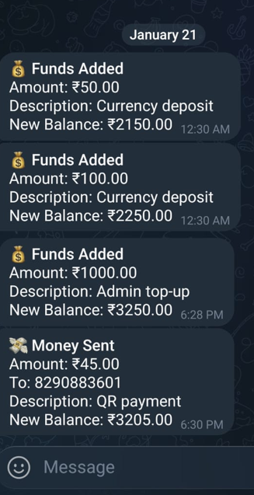
Fig. 5.1

FLOWCHART

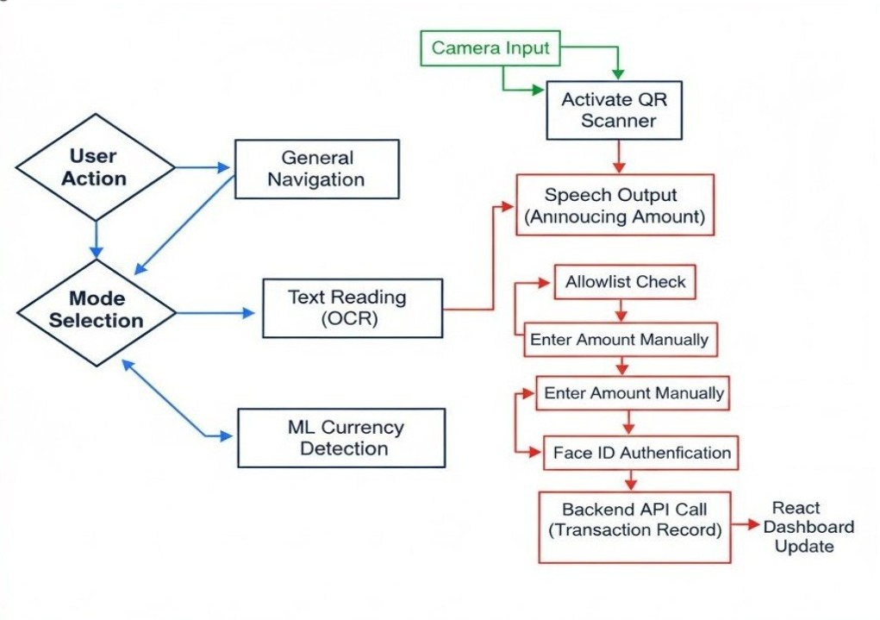
Fig 5.2
VI. RESULTS AND DISCUSSION

- Evaluation Setup and Testing Conditions

Second Sight was evaluated through controlled functional tests and an offline currency-model comparison. Both currency classifiers were tested on the same held-out set of 293 images spanning ₹10, ₹20, ₹50, ₹100, ₹200, and ₹500 notes. The dataset was checked for exact train-test duplicates and none were found. Additional device tests covered empty scenes, keyboard OCR, mode switching, QR validation, Face ID gating, backend updates, dashboard synchronization, and the Describe request path. LM Studio was verified to expose MiniCPM-V 4.6 and accept image input through its OpenAI-compatible endpoint.

- Obstacle Detection Performance and Navigation Feedback Quality

The object detection pipeline successfully identified major obstacles relevant to navigation, particularly human presence and common furniture. The filtering and non-maximum suppression logic reduced duplicate detections, while smoothing improved stability across frames. Speech-based obstacle feedback was found to be effective when limited to critical classes, as this prevented excessive announcements and improved user comprehension. The position estimation mechanism based on bounding box midpoint provided meaningful directional guidance, allowing the system to communicate whether an obstacle was primarily on the left, center, or right. Although distance estimation was heuristic, it produced useful approximate cues that could inform safer movement decisions, particularly in indoor environments where objects appear at predictable relative sizes. The results indicate that the obstacle detection module provides practical real-time assistance, though accuracy could be further improved with depth sensing integration.
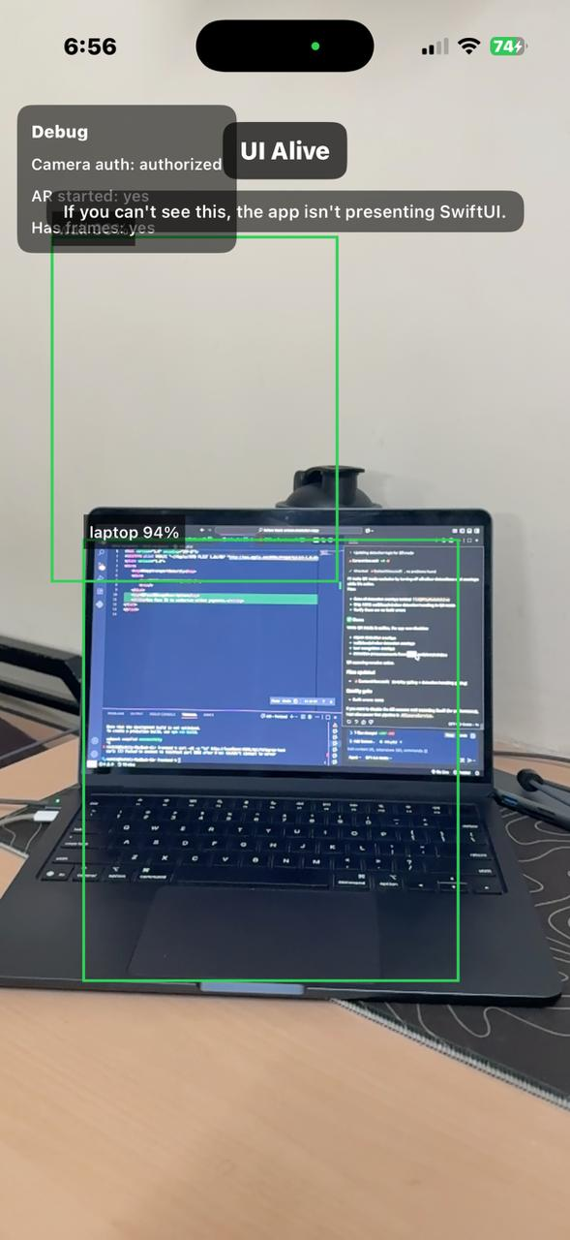
Fig 6.1

- OCR Recognition Reliability and Controlled Reading Behavior

The revised OCR subsystem reduced irrelevant speech by filtering at both recognition and tap-to-read stages. Accurate Vision OCR, language correction, a 0.55 confidence threshold, minimum-area filtering, keyboard-sequence rejection, fragmented-character rejection, and lexical checks prevent key rows and random visual patterns from being read aloud. Useful signs, prices, numbers, and common abbreviations remain available through the user-controlled prompt-and-tap interaction.

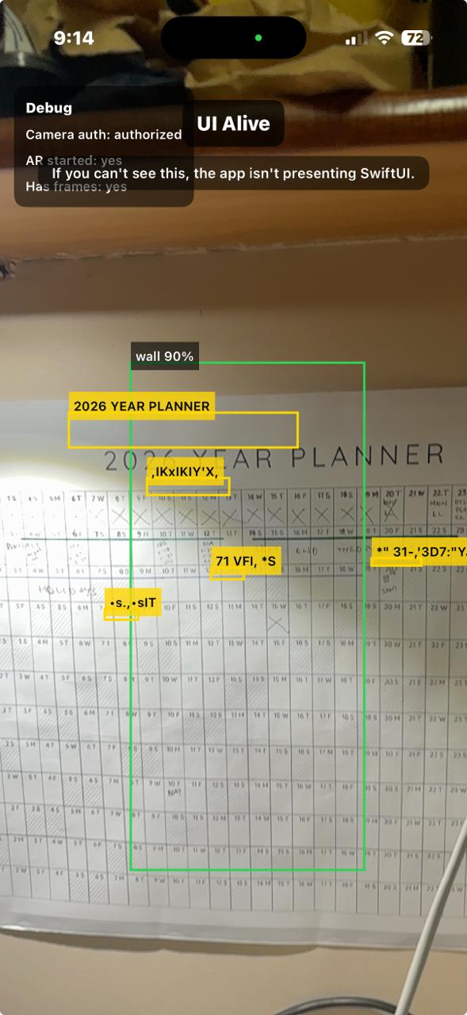
Fig 6.2
- Currency Model Comparison, Stability, and Practical Usability

On the common 293-image test set, the previous Core ML model correctly classified 47 images (16.0%), whereas the trained TensorFlow Lite model correctly classified 267 images (91.1%). New-model class accuracy was 86.8% for ₹10, 93.3% for ₹20, 97.7% for ₹50, 79.1% for ₹100, 96.1% for ₹200, and 92.9% for ₹500. The older model’s corresponding scores were 1.9%, 3.3%, 4.5%, 2.3%, 0.0%, and 97.6%. Because this benchmark comes from the new model’s six-class dataset and excludes ₹2000, the result demonstrates suitability for the current deployment rather than universal superiority across every capture distribution.
The deployment was further hardened with note-shape detection, probability-margin rejection, two-frame consecutive consensus, active clearing of empty scenes, and OCR corroboration. These controls address the classifier’s closed-set behavior: without an explicit background class, a softmax classifier always ranks some denomination even when no note is present.
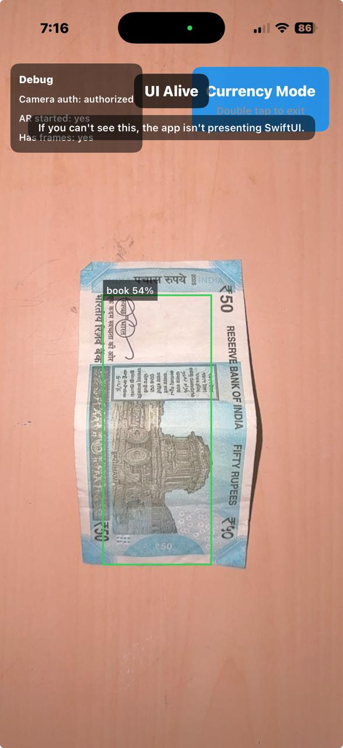
Fig 6.3

- QR Pay Mode Security and End-to-End Transaction Validation

QR Pay Mode achieved reliable QR detection and secure transaction execution through its exclusive mode design and strict authentication pipeline. Allowlist validation ensured that only trusted QR payloads could initiate payment, preventing arbitrary QR codes from triggering wallet transfers. Normalization improved matching reliability across formatting differences, which reduced false rejections of valid QR codes. Manual amount entry ensured that QR payloads did not encode transaction values, thereby preventing malicious manipulation where a QR might force a large unintended amount. Speaking the amount aloud provided an additional confirmation step for blind users. Face ID authorization served as the strongest security barrier, ensuring that payments could not proceed without biometric approval. The end-to-end workflow consistently updated wallet balance in the backend and recorded transaction history in MongoDB. The React dashboard reflected changes through polling, confirming system-wide consistency. Telegram notification delivery was dependent on correct bot configuration and chat permissions, and while it was not guaranteed in all environments, it did not affect wallet correctness. Overall, QR Pay Mode demonstrated that secure wallet transfers can be integrated into an assistive application without compromising accessibility.
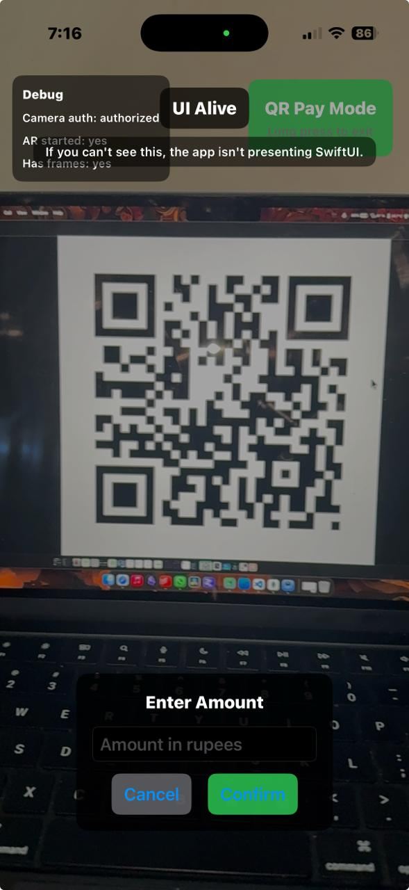
Fig 6.4

- Operational Observations and Practical Limitations

During evaluation, backend addressing was found to differ between simulator and physical-device operation: an iPhone requires the Mac’s LAN address rather than localhost. The Describe feature requires the backend, LM Studio, and the loaded MiniCPM-V 4.6 vision model to remain reachable on the same network; if those services are unavailable, on-device obstacle, OCR, and currency features continue to operate. The current currency model covers six denominations and has no explicit background or ₹2000 class; geometric, confidence, OCR, and temporal rejection reduce this limitation, while future retraining should add representative non-currency images. Distance estimation remains approximate without depth sensing, and older devices may experience thermal or frame-rate constraints.

VII. CONCLUSION

This paper presented Second Sight, an assistive iOS system integrating navigation feedback, meaningful text reading, Indian currency recognition, the AI-powered Describe feature, and secure QR wallet transfers. Describe uses MiniCPM-V 4.6 through LM Studio to convert a live camera frame into a concise spoken scene summary. ARKit supplies camera frames; Vision and Core ML perform obstacle detection; Vision OCR uses semantic filtering; and the trained TensorFlow Lite currency classifier achieved 91.1% accuracy on the shared 293-image benchmark compared with 16.0% for the removed Core ML model. Note-presence gating and consecutive consensus reduce empty-scene false positives, while the filtered tap-to-read workflow suppresses keyboard and gibberish output. Face ID-gated QR payments, MongoDB persistence, Telegram alerts, and dashboard monitoring complete the system.

VIII. FUTURE WORK AND POSSIBLE EXPANSION
Future enhancements to Second Sight can improve recognition accuracy, navigation intelligence, and deployment scalability. Obstacle distance estimation can be significantly improved by integrating ARKit depth maps and LiDAR-based sensing on supported devices, enabling accurate distance reporting and safer movement guidance. The navigation subsystem can be extended to provide route-level assistance by integrating GPS for outdoor environments and indoor localization techniques such as BLE beacons or visual anchors. OCR can be expanded to support multilingual recognition and speech output, enabling Second Sight to operate effectively in diverse Indian language environments. Currency recognition can be strengthened through improved datasets, enhanced blur handling, and adaptive exposure control to support reliable detection under challenging lighting conditions. The backend system can be deployed on secure cloud infrastructure with authentication, encrypted communication, and user-specific wallets for real-world scalability. Additional accessibility improvements such as haptic feedback integration, wearable support, and emergency SOS features can further improve user safety. Finally, large-scale user studies involving BVI participants can provide quantitative evaluation metrics and guide refinement of interaction design, speech strategies, and system reliability.
ViI. Acknowledgement
The authors would like to express their sincere gratitude to the faculty mentors and project coordinators of the Experiential Learning (EL) Program at RV College of Engineering for their guidance, encouragement, and continuous support throughout the development of the Second Sight project. The collaborative environment and valuable feedback received during various review phases significantly contributed to the successful completion of this work.

VIII. References
[1] N. Kumar and A. Jain, “A Deep Learning Based Model to Assist Blind People in Their Navigation,” Proc. Int. Conf. on Intelligent Systems and Data Science, 2025.

[2] B. Kuriakose, S. Mathew and P. Thomas, “DeepNAVI: A Deep Learning Based Smartphone Navigation Assistant for the Visually Impaired,” *Expert Systems with Applications*, vol. 204, pp. 118–331, 2023.

[3] P. Kathiria, A. Jain and R. Gupta, “Smart Assistive Navigation System for Visually Impaired People,” Proc. 2025 IEEE Int. Conf. on Assistive Tech., pp. 21–29.

[4] S. M. Rathore, M. Imran, S. Ahmad and A. Khan, “A Smart Assistive System for Visually Impaired People Through Object Detection Using Tunicate Swarm Algorithm (SASVCP-ODTSA),” *Sci. Rep.*, vol. 15, Art. no. 10897, 2025.

[5] M. A. Hussain and F. Arif, “Assistive Systems for Visually Impaired People: A Comprehensive Survey,” *Neurocomputing*, vol. 540, pp. 141–159, 2024.

[6] S. Patel and R. Singh, “Artificial Intelligence for Visually Impaired: A Review of Techniques and Systems,” *J. of Vis. Comput. Assist. Technol.*, vol. 8, no. 2, pp. 12–27, 2024.

[7] A. Lavric, S. Popescu and D. Petrescu, “A Comprehensive Survey on Emerging Assistive Technologies for the Visually Impaired,” *Sensors*, vol. 24, no. 15, Art. no. 4834, 2024.

[8] J. Sharma and K. Reddy, “Assistive Technologies for the Visually Impaired: A Review,” *Cureus*, vol. 16, no. 1, Art. no. e6891, 2024.

[9] L. Zhang, J. Wang and X. Li, “Review of Navigation Assistive Tools and Technologies for Visually Impaired,” *IEEE Access*, vol. 10, pp. 103211–103234, 2022.

[10] T. Nguyen, H. Lee and J. Park, “An Effective Obstacle Detection System Using Deep Learning,” *Pattern Recognit. Lett.*, vol. 185, pp. 142–150, 2023.

[11] A. Singh and M. Sharma, “Adaptive Object Detection for Indoor Navigation Assistance,” *arXiv:2501.18444*, Jan. 2025.

[12] S. K. Das and R. Banerjee, “Object Localization Assistive System Based on CV and Vibrotactile Encoding,” *arXiv:2206.09432*, Jun. 2022.

[13] R. B. Patel and Y. K. Desai, “A Visually Impaired Mobile Application for Currency Recognition Using MobileNetV2 CNN Architecture,” Int. J. of Comput. Appl., vol. 182, no. 7, pp. 18–25, 2024.

[14] M. R. Mehta, P. Singh and A. Gupta, “Visual Recognition for Blind People: Integration of Object Detection, OCR, and Currency Recognition,” *Int. J. of Signal and Image Processing*, vol. 12, no. 3, pp. 87–102, 2024.

[15] Q. Li and X. Zhou, “LLM-Glasses: GenAI-Driven Glasses with Haptic Feedback for Navigation of Visually Impaired People,” *arXiv:2503.16475*, Mar. 2025.

[16] S. Roy and T. Chakraborty, “Smart Glasses for the Visually Impaired People,” *Int. J. of Emerging Tech. in Eng.*, vol. 12, no. 5, pp. 301–310, 2023.

[17] A. Nair and L. Singh, “AI-Powered Assistive System for the Visually Impaired,” Int. J. of Creative Research Thoughts, vol. 11, no. 4, pp. 2204–2212, 2023.

[18] N. Verma and R. Mishra, “AI-Smart Cane Technology and Assistive Navigation for Visually Impaired,” *Smart Health*, vol. 25, Art. no. 200351, 2025.

[19] H. Kim and J. Choi, “A Wearable Navigation Device for Visually Impaired Using Semantic SLAM and Segmentation,” *Sensors*, vol. 21, no. 4, Art. no. 1536, 2021.

[20] L. Xu, “AIris: An AI-Powered Wearable Assistive Device for Visually Impaired Individuals,” *arXiv:2405.07606v1*, May 2024.

